There is an undirected tree with n nodes labeled from 1 to n. You are given the integer n and a 2D integer array edges of length n - 1, where edges[i] = [ui, vi] indicates that there is an edge between nodes ui and vi in the tree.

Return *the* ***number of valid paths*** *in the tree*.

A path (a, b) is **valid** if there exists **exactly one** prime number among the node labels in the path from a to b.

**Note** that:

* The path (a, b) is a sequence of **distinct** nodes starting with node a and ending with node b such that every two adjacent nodes in the sequence share an edge in the tree.
* Path (a, b) and path (b, a) are considered the **same** and counted only **once**.

**Example 1:**

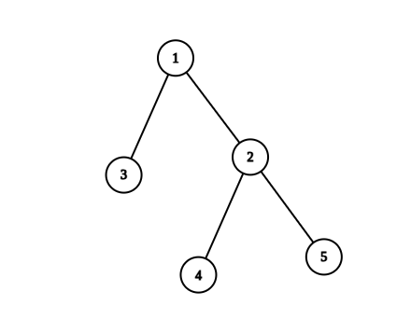

Input: n = 5, edges = [[1,2],[1,3],[2,4],[2,5]]  
Output: 4  
Explanation: The pairs with exactly one prime number on the path between them are:   
- (1, 2) since the path from 1 to 2 contains prime number 2.   
- (1, 3) since the path from 1 to 3 contains prime number 3.  
- (1, 4) since the path from 1 to 4 contains prime number 2.  
- (2, 4) since the path from 2 to 4 contains prime number 2.  
It can be shown that there are only 4 valid paths.

**Example 2:**

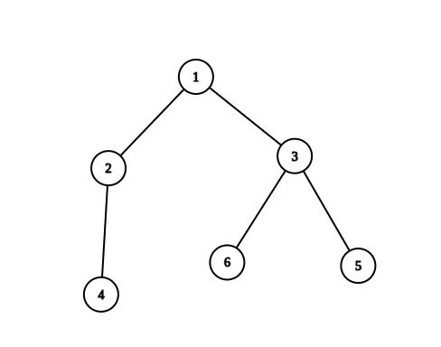

Input: n = 6, edges = [[1,2],[1,3],[2,4],[3,5],[3,6]]  
Output: 6  
Explanation: The pairs with exactly one prime number on the path between them are:   
- (1, 2) since the path from 1 to 2 contains prime number 2.  
- (1, 3) since the path from 1 to 3 contains prime number 3.  
- (1, 4) since the path from 1 to 4 contains prime number 2.  
- (1, 6) since the path from 1 to 6 contains prime number 3.  
- (2, 4) since the path from 2 to 4 contains prime number 2.  
- (3, 6) since the path from 3 to 6 contains prime number 3.  
It can be shown that there are only 6 valid paths.

**Constraints:**

* 1 <= n <= 105
* edges.length == n - 1
* edges[i].length == 2
* 1 <= ui, vi <= n
* The input is generated such that edges represent a valid tree.